**Scenario: You have submitted a paper to a conference and you have gotten the comments. You need to know the comments about “communication” in your paper, and you want to see what part of paper was mostly.**

**We have made a system that extracts information of articles and allows analysis based on them. We want to compare directly checking the paper reviews and the output of analysis of the extracted information.**

Please do these two tasks then answer the questionnaire.

**TASK** 1.

1. **checkout comments performed by Reviewer2 about “communication” and say that comment was too general?**

1. Using this link <https://afshin.databox.me/public/Article1.html#2987879860>
2. Using the an automatic system that searches the word comment between comments and shows the response shown below this image

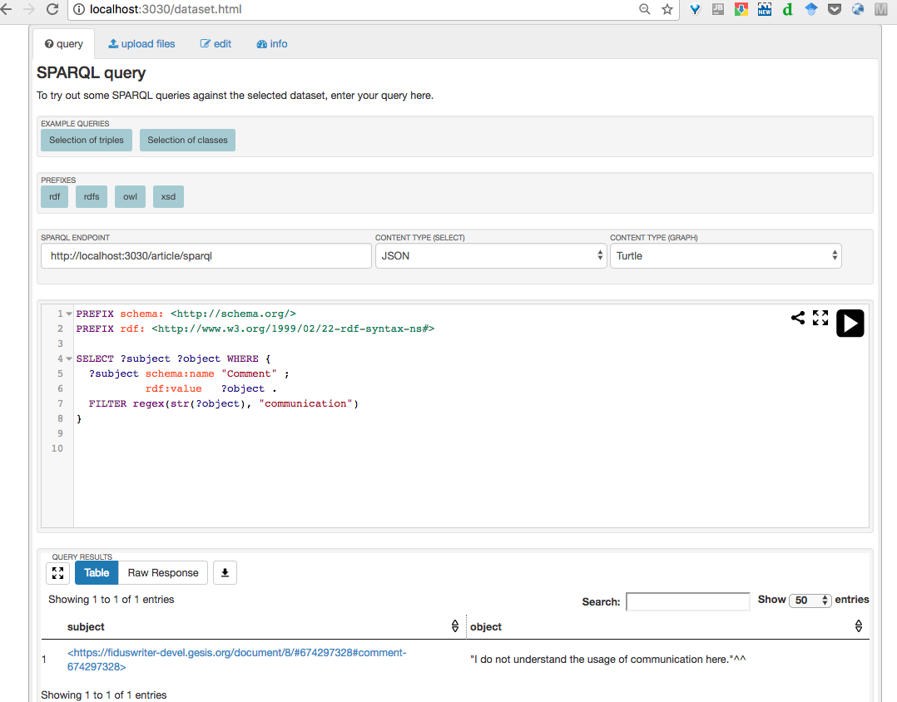

**TASK** 2.

**2. Find out the most commented section in the article.**

1. Using this link <https://afshin.databox.me/public/Article1.html#2987879860>
2. Using the result of the analysis shown below this image

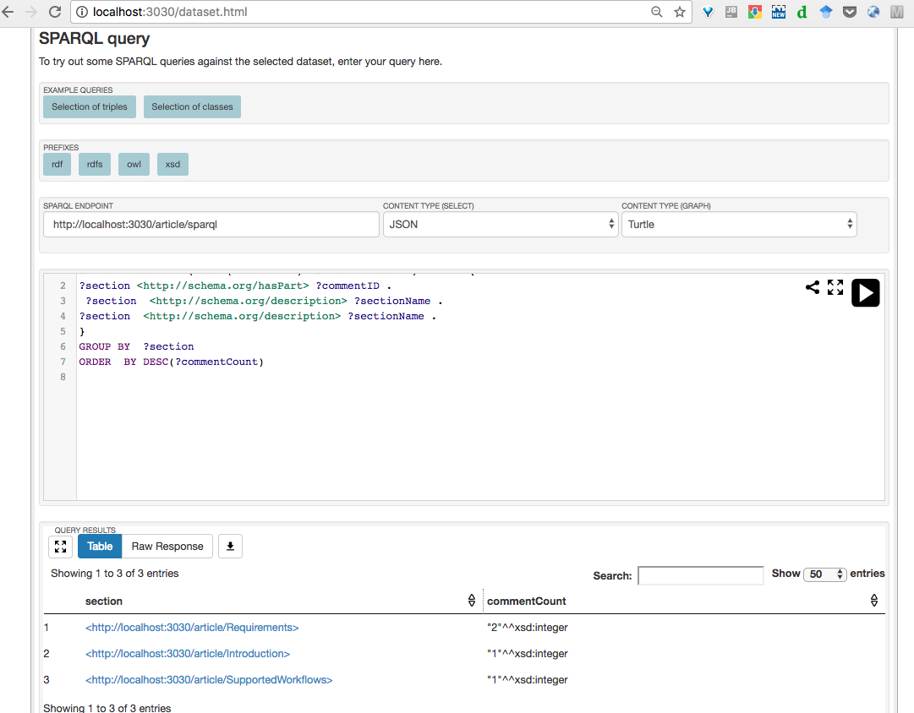

**Overall reaction to the system**

1. Between 1. **terrible** to 9. **Wonderful** what point do you give. 6
2. Between 1. **difficult** to 9. **easy** what point do you give. 5
3. Between 1. **frustrating** to 9. **satisfying** what point do you give. 7
4. Between 1. **Inadequate** **power** to 9. **adequate** **power** what point do you give. 6
5. Between 1. **dull** to 9. **stimulating** what point do you give. 7
6. Between 1. **rigid** to 9. **flexible** what point do you give. 6

**Learning**

1.Have you ever reviewed a paper? yes

2. Learning required to do the task? Yes, needs some explanation

3. Remembering the names and use of commands? The system game partially ambiguous information

4.Performing tasks is straightforward? The task needed a bit explanation

5.Supplemental reference materials? Did not required for me

**System Capabilities**

6.System speed? Of course the system is faster

7.System reliability? For the second task it looked reliable but for the first task I think it was partial reliable

8.System tends to be? helpful

9.Correcting your mistakes? For the second task

I found one per section but the system gave 2 for the first and one for the others

10. Designed for all levels of users?

It needed some experiences

List of the most Negative aspects?

1. The description of result was somehow ambiguous

2.

3.

List of the most Positive aspects?

1. Faster
2. User needs less effort when use the system instead of reading comments directly

3.